# Game-Dev Task

## Spy Me: The Orb of Obedience

After years of plotting, Vector has finally done the unthinkable

 

— he defeated Gru and taken control of all the Minions.

But he didn’t do it alone. Teaming up with his mysterious sister, **Hexa Von Vectorius**, a techno-witch with a talent for mixing magic and machines, Vector used an ancient relic known as the **Orb of Obedience** to cast a powerful spell over the Minions, turning them into loyal patrolling guards.

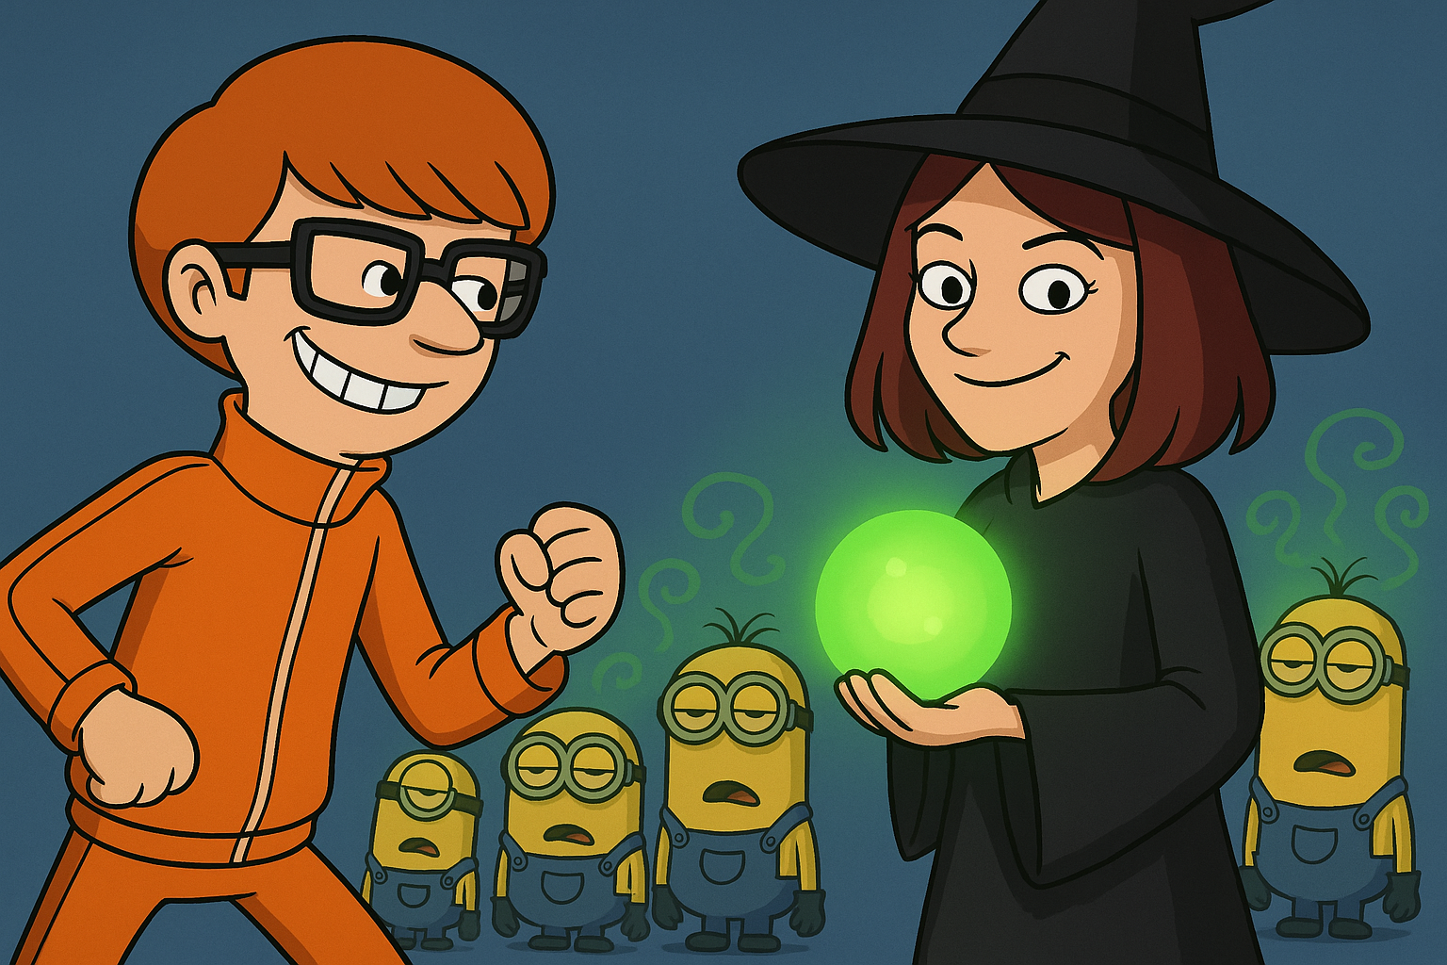

He’s hidden the Orb deep within a high-security fortress buried in the icy peaks of the Himalayas, surrounded by lasers, and a maze of mind-controlled minions. Desperate to stop Vector and free the Minions, Gru has secretly recruited **you**, a highly trained stealth operative wearing the experimental **Stealth-Suit**, combining ninja agility with futuristic tech. Your mission is simple: infiltrate Vector’s Mountain stronghold, recover the Orb, and break the spell before it’s too late.

After months of search and infiltration attempts, you have finally reached the place where the orb is hidden, but it is heavily guarded by the minions. Remember! this is your shot now!

The fate of the Minions — and maybe the world — is in your hands.